**PHOTO ESSAY**

**WACHIRA WINNIE NJERI**

**C027-01-1366/2019**

**IGS 4101/4202**

**CRITICAL THINKING AND COMMUNICATION SKILLS**

**(CAPSTONE PROJECT)**

**BRIDGING THE DIGITAL DIVIDE IN AFRICA**

**Introduction**

Africa, a continent pulsating with vitality, harbors immense potential in its youthful population, vibrant cultures, and abundant resources. However, amidst this promise lies a formidable barrier: the gaping chasm of inequitable access to technology and education, particularly pronounced in rural regions. This photographic narrative delves into the profound repercussions of the digital divide and the ongoing endeavors to surmount it.

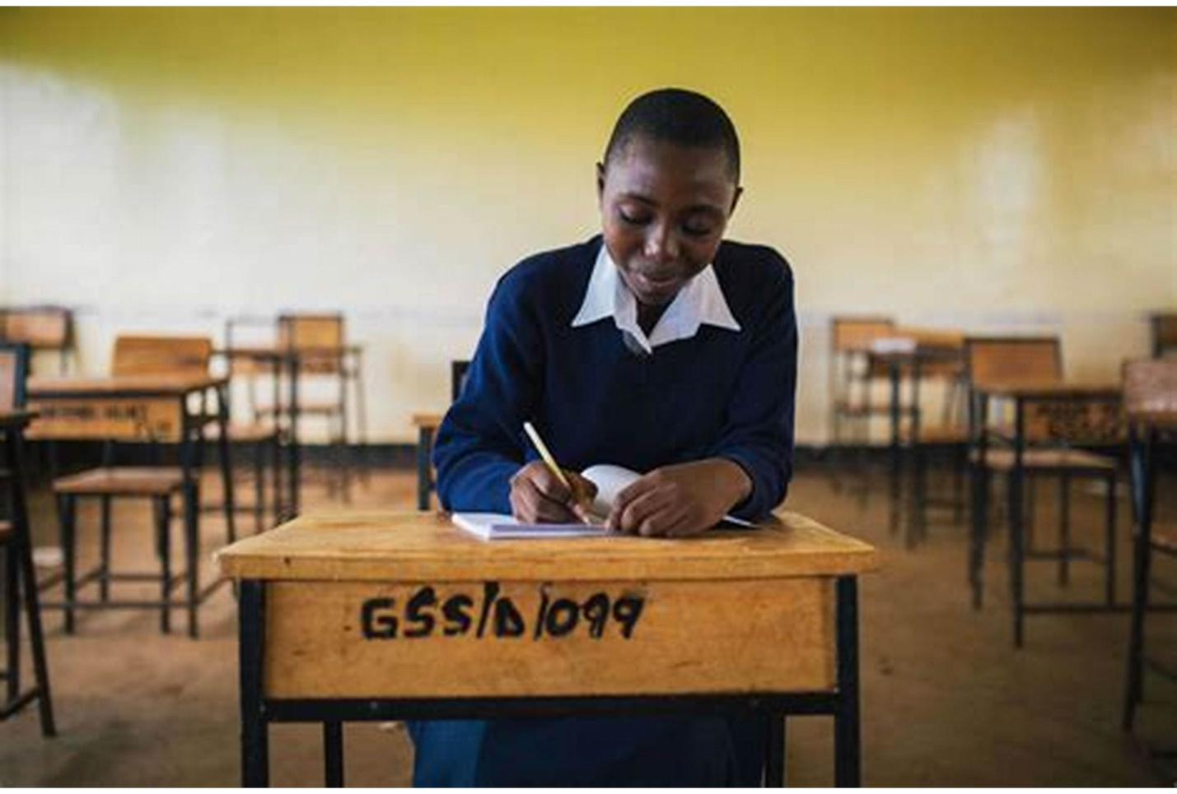

In rural Africa, educational institutions often languish in the shadows of resource scarcity. Outdated textbooks, limited infrastructure, and a dearth of digital devices underscore the uphill battle students face in accessing a contemporary education. This solitary figure epitomizes the longing shared by many for the transformative power technology promises but remains out of reach.

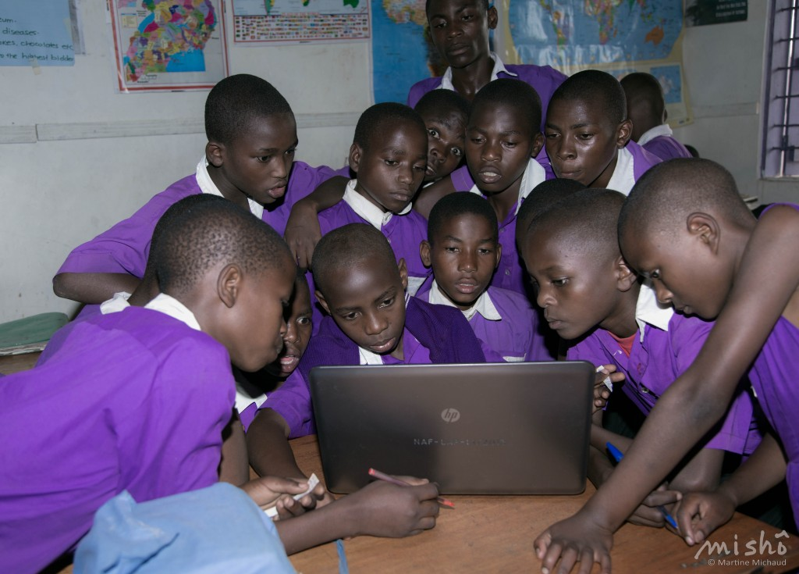

Where technology manages to infiltrate educational settings, its presence is tenuous at best. Outmoded equipment, insufficient in quantity, relegates students to a cycle of shared access, stifling their potential to fully immerse themselves in the digital landscape. This tableau encapsulates the struggle inherent in navigating a world where access to information is a privilege, not a right.

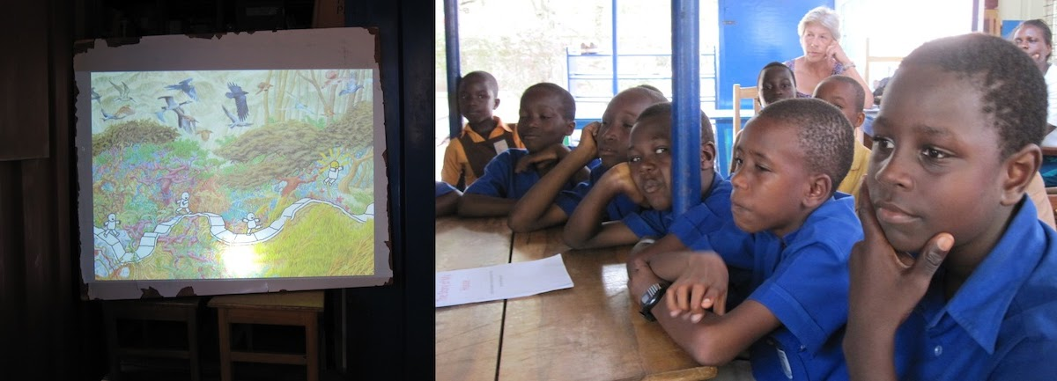

Yet, amidst the adversity, ingenuity blossoms. Resourceful educators seize upon alternative avenues to disseminate knowledge, transcending the confines of traditional classrooms. Here, under the open canopy of the sky, communal learning takes center stage, fueled by the collective thirst for enlightenment.



Innovative initiatives herald a new dawn of accessibility, as technology is mobilized to traverse the geographical expanse separating remote communities from the digital age. This nomadic hub of learning, powered by renewable energy, symbolizes the transformative potential of technology when wielded as a tool for inclusivity.



For Africa, the digital divide transcends mere educational disparity, morphing into a formidable social and economic impediment. Yet, in nurturing the digital acumen of its youth, the continent finds a beacon of hope. This image encapsulates the transformative potential of digital literacy, empowering individuals to chart a course towards a more interconnected and equitable future.

As stakeholders unite in common cause, weaving a tapestry of collaboration between governments, NGOs, and local communities, the prospect of bridging the digital divide looms ever closer. It is a journey fraught with challenges, demanding sustained investment, innovative solutions, and an unwavering commitment to nurturing the potential of Africa's burgeoning youth. In each image lies not only a testament to the obstacles yet to be surmounted but also a beacon of hope illuminating the path towards a future where education and technology converge to unlock the boundless potential of the African continent.